SELECT with various clause – WHERE, pattern matching

AIM:
To view the records from the tables using SELECT commands with WHERE Clause and Pattern matching.

DESCRIPTION:
The SELECT statement allows you to get the data from tables. A table consists of rows and columns like a spreadsheet. Often, you want to see a subset rows, a subset of columns, or a combination of two. The result of the SELECT statement is called a result set that is a list of rows, each consisting of the same number of columns.

PART A — WHERE CLAUSE
The WHERE clause is used to filter rows from the result.

QUESTION 1
Display the customer name, token number and juice name of all customers.

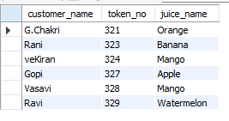

QUESTION 2
Display all customers who paid using UPI.
SELECT *
FROM juiceshopc
WHERE payment_mode = 'UPI';

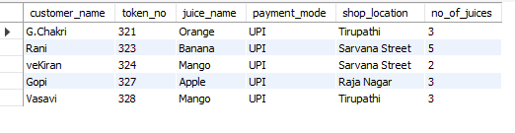
QUESTION 3
Display all customers who purchased Mango juice.
Run:
SELECT *
FROM juiceshopc
WHERE juice_name = 'Mango';
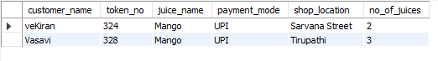

QUESTION 4
Display all customers from Tirupathi.
Run:
SELECT *
FROM juiceshopc
WHERE shop_location = 'Tirupathi';
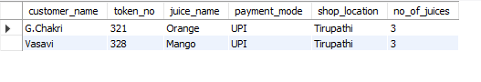
QUESTION 5
Display customers who purchased more than 2 juices.
Run:
SELECT *
FROM juiceshopc
WHERE no_of_juices > 2;
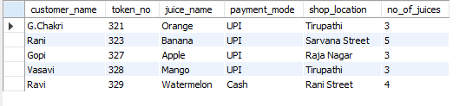

PART B — LIKE / PATTERN MATCHING
The LIKE operator is used to search data using patterns.
Remember:
% = zero or more characters
_ = exactly one character
These are the two wildcards described in your manual.

QUESTION 6
List customers whose names start with R.
Use % after R:
SELECT *
FROM juiceshopc
WHERE customer_name LIKE 'R%';

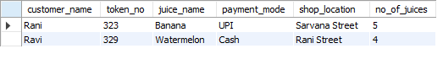
QUESTION 7
List customers whose names end with i.
Use % before i:

SELECT *
FROM juiceshopc
WHERE customer_name LIKE '%i';

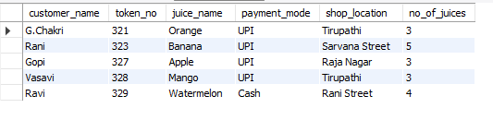

QUESTION 8
Display customers whose juice name contains app.
Use % on both sides:
SELECT *
FROM juiceshopc
WHERE juice_name LIKE '%app%';
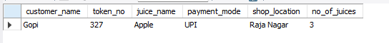
QUESTION 9
Display customers whose shop location contains Street.
Run:
SELECT *
FROM juiceshopc
WHERE shop_location LIKE '%Street%';
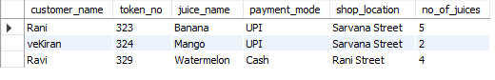

RESULT
The records from the juiceshopc table were successfully displayed using SELECT commands with the WHERE clause and LIKE pattern matching.

